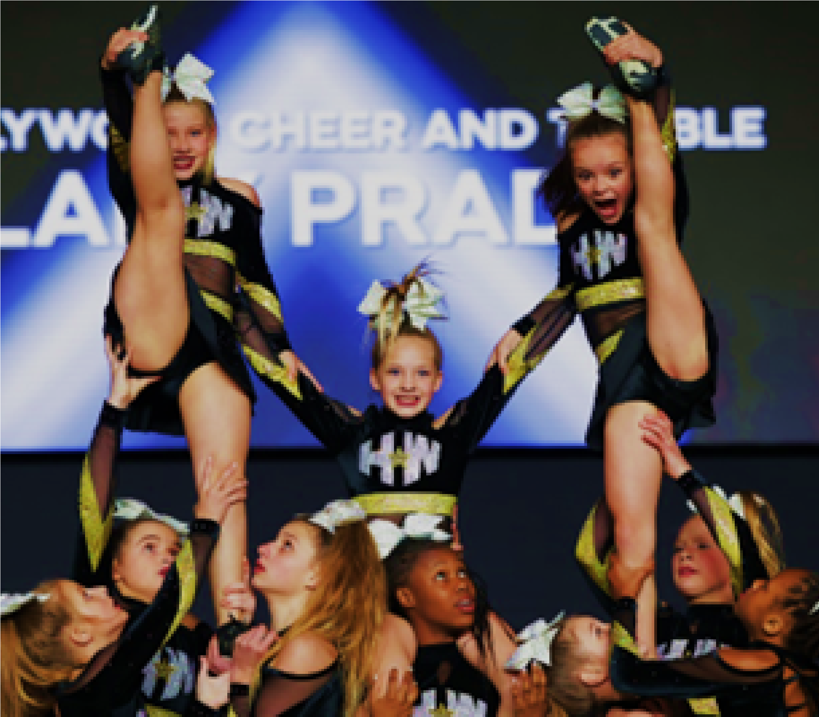
TRYOUT PACKET
2024-2025

COMMITTMENT

The performance teams are a year long commitment for you, your athlete, and the teams.
The new season begins June 1, 2024. You are responsible for tuition and all fees during the entirety of the season; tuition/expenses,
practices and absences will be broken down on the following pages.

Important dates:
Placements: May 17th, May 18th, May 19th
Skills camp: July 26th, July 27th, July 28th
Choreography: August/September

EXPENSES
TUITION

All team members must pay fees even if they cannot participate due to illness, injury, etc. All athletes are a crucial part to the team for the entire season, even if they are not on the mat. There is no prorating or make-up classes for the All-Star program.
Tuition is to be paid a month prior in order for your athlete to participate in practice and avoid a late fee of $40. This is a gym rule and not only an All-Star program rule. Tuition payment is due on the 15th of each month and is late on the 20th. If tuition has not been paid by the 20th, the late fee will be added to your account. Credit card payments are subject to a 4% processing fee. To avoid this, you can pay by cash or check. Checks for tuition are made out to Famous Kids LLC. Tuition is based on the team that your athlete is placed on.

TUITION

FULL SEASON (MINI NOVICE): $160.00/MONTH
FULL SEASON (MINI ELITE): $180.00/MONTH
FULL SEASON (YOUTH-SENIOR): $340.00/MONTH
Ask us about discounted optional classes if you are apart of our All-Star program!

In addition to monthly tuition, please expect the following bundle package expenses throughout the season. See Bundle Packages for a breakdown of items. Prices vary per team.

This season athletes will be in charge of getting their own practice wear Athletes will bring these items to the gym for the logo to be put on. There will be a fee for this. Athletes are to get black Nike Pro spanks, Dri fit running shorts and black Dri Fit tank or sports bra. Minis will get the same apparel (doesn’t have to be Nike) These items are already picked out. We have pictures of all items.

BUNDLE PACKAGES

BUNDLED PACKAGE FOR NEW MINI ATHLETES:
- CHOREOGRAPHY & MUSIC: SESSIONS IN AUGUST AND SEPTEMBER
- SKILLS CAMP: JULY 26TH THROUGH JULY 28TH
- PRACTICE WEAR:
  - ONE TEAM T-SHIRT
  - ONE HOLLYWOOD T-SHIRT
  - PRACTICE SCRUNCHIE & COMPETITION BOW
  - UNIFORM: ~ $200.00 -250.00

BUNDLED PACKAGE FOR NEW YOUTH-JUNIOR-SENIOR ATHLETES:
- CHOREOGRAPHY & MUSIC: SESSIONS IN AUGUST AND SEPTEMBER
- SKILLS CAMP: JULY 26TH THROUGH JULY 28TH
- PRACTICE WEAR:
  - ONE TEAM T-SHIRT
  - ONE HOLLYWOOD T-SHIRT
  - PRACTICE SCRUNCHIE & COMPETITION BOW
- UNIFORM: ~ Youth-Junior-Senior $635.00

BUNDLE PACKAGE FOR RETURNING ATHLETES:
- CHOREOGRAPHY: AUGUST / SEPTEMBER
- SKILLS CAMP: JULY 26TH THROUGH JULY 28TH
- PRACTICE WEAR:
  - ONE TEAM T-SHIRT
  - ONE HOLLYWOOD T-SHIRT
  - PRACTICE SCRUNCHIE
  - COMPETITION BOW IF NEW ONE IS NEEDED ~ $40.00
PRACTICES
Practice is MANDATORY the two weeks prior to any competition or performance. Staff reserve the right to replace any athlete not in attendance during this time frame in preparation for competition.
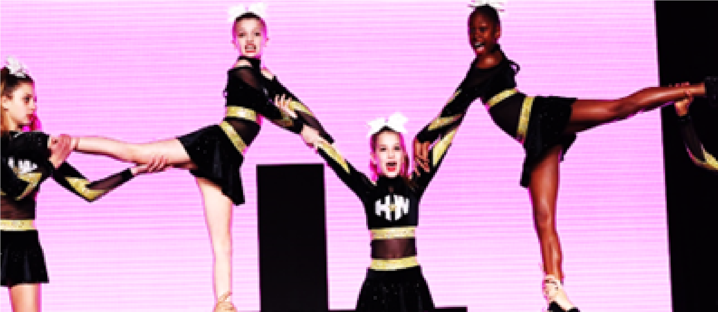
Athletes are expected to attend all practices and will carry a positive attitude towards other teammates and coaches. Absences will be excused for graded school activities, medical emergencies, and approved circumstances by staff. For any anticipated absences, an absence request form needs to be filled out and turned into the team’s coach. Athletes are to ensure that the performance teams come first above other activities! If too many absences are incurred, your athlete may be subject to being moved in their routine.
Athletes need to arrive to practice ON TIME and wearing the proper attire, hair up in a ponytail with their practice scrunchie, and clean cheer shoes. No jewelry is to be worn during practice, tumbling lessons, or competitions.
The athletes must understand that they are to always conduct themselves in a professional manner. No foul language, bullying, gossiping, negative attitudes, or violence are allowed.
Extra practices may be scheduled one to two weeks before a competition in preparation for the team’s performance. These practices are assigned based on team needs.

ABSENCES & EXPECTATIONS

All athletes must attend summer training for youth, junior and senior levels to be placed on a team. There is no taking the summer off and returning in the fall. Any vacations or commitments during the summer must be turned in during parent interviews. All athletes are required to attend their skill camp training and choreography. All athletes must take a tumbling class; two is preferable, or a private class in place of the second class. All flyers must be in flight school.
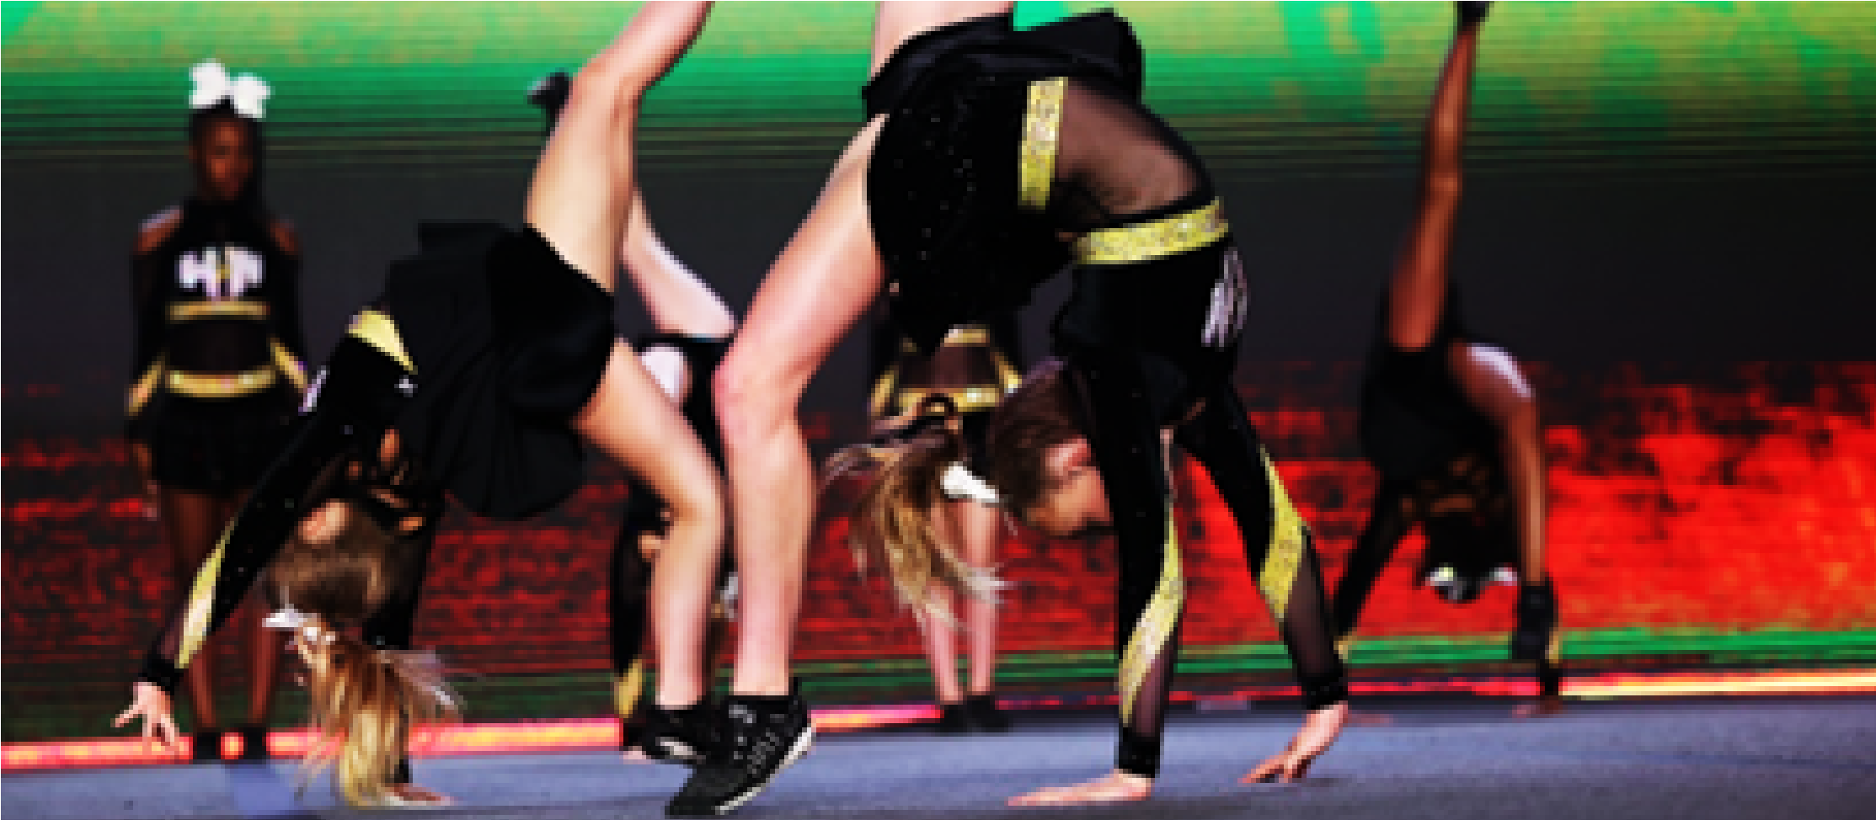
The decision to move athletes from one team to another, or have them compete on more than one team, is entirely up to the coaches and Hollywood staff. This will be based upon the athlete’s skills/ability, dedication, attitude, and the team’s need throughout the competition season. Your child must meet the requirements after making a team or your child may become an alternate until these requirements are met. For instance, they will become an alternate or move down a level if they try out with a round-off backhand spring tuck and do not keep the skill. Please trust in the program as our coaches are thoroughly educated on the score sheets!
All injuries must be promptly reported to your head coach and front desk staff. In order to maintain strength and flexibility, as well as support the team, any team member that is injured is still expected to attend practices to condition and stretch.
If any parents, students, or staff have a concern, there is a designated box for anonymous or signed letters that will be checked on a weekly basis. If your concern is more urgent, please email the HWdesk11@gmail.com account to set up a time to meet and discuss any issues. Approaching a coach or staff member during practice takes time away from the athletes.

